# Data Mining Assignment

Data Mining Assignment 1

1.0 Introduction 1

Data Summary 2

2.0 Headline 2

2.1 Short description 2

2.2 Authors 3

2.3 Link 3

2.4 Date 3

2.5 Category 3

3.0 Data Pre Processing 5

3.1 Count Vectorizer 6

3.2 TF-IDF 7

4.0 Data Mining Algorithms 8

Naïve Bayes 8

Decision Tree 9

Random Forest 11

5 Modeling 14

Experiment one (Naïve Bayes) 14

Experiment Two (Decision Tree) 15

Experiment Three (Random Forest) 16

Experiment Four (Support Vector Machine) 17

Experiment Five (Logistic Regression) 18

**Data visualization *19***

**Final results and conclusion 24**

**Individual Contribution 24**

**References 26**

## 1.0 Introduction

There exists a lot of data being put away in the electronic arrangement. With such information it has become a need of such implies that could decipher and examine such information and concentrate such realities that could help in dynamic. Data mining which is utilized for separating concealed data from gigantic databases is a powerful instrument that is utilized for this reason. News data was not effectively and rapidly accessible until the start of a decade ago. Be that as it may, presently news is effectively open through substance suppliers, for example, online news administrations.

A gigantic measure of data exists in type of content in different various zones whose examination can be helpful in a few regions. Arrangement is a significant testing field in content mining as it requires predisposing steps to convert unstructured information to organized data. With the expansion in the quantity of news it has troublesome for clients to get to updates on his advantage which makes it a need to classifications news with the goal that it could be without any problem gotten to. Arrangement alludes to gathering that permits simpler route among articles. Web news needs to be partitioned into classifications. This will assist clients with accessing the updates on their enthusiasm for ongoing without squandering whenever. With regards to news it is a lot of hard to order as news are constantly giving the idea that need to be prepared and those news could be never-seen and could fall in another classification.

In this project we have taken a news data from kaggle. This contains 200k news.

The news data contained 6 columns and 200853 rows (samples) in which category column is our target column.

Headline | authors | link | short description | date | category

Attributes:

Terminology:

Task / Scenario / Project all refer to the situation of which this report and data mining project has been presented. The terminology refers to the scenario of the financial establishment, and the end goal of predicting the probable chance of future loans being repaid by customers.

Financial Establishment refers to the bank in which the data saws supplied from.

Record(s) refer to the individual data variables for each row within the provided dataset.

Red text within tables (Data Summary section) indicated flagged issues, which may affect the data, or should be attended to.

Instances / Customers / Individuals / Person / Applicant all refer to an individual set of values for one unique person. One person has 15 attributes, and can be identified by their Customer ID.

Record(s) refer to the results of a particular customer or customers. NB found in chapter 4 (table data) is shorthand for Naive Bayes.

In the Modelling section: **D** = Defaulted | **P** = Paid Mean refers to the average of a set o

## Data Summary

### Headline

#### String

In this feature we have headlines of news for examples this is the headline for the first sample in the data set **‘There Were 2 Mass Shootings in Texas Last Week, But Only 1 on TV’**

|  |  |  |  |
| --- | --- | --- | --- |
| **Headline (Attribute)** | **Missing** | **Same** | **Unique** |
| **Num of samples** | 0 | 1509 | 199344 |
| **Percentage** | 0% | 0.7% | 99.3% |

Ok it seem that there are duplicates records but actuals it’s not because some of the news have same headlines but different short description and date. Let’s see an example a row number 366 and 698.

|  |  |  |  |  |  |  |  |
| --- | --- | --- | --- | --- | --- | --- | --- |
| **(index)** | **Headline** | **Short description** | **authors** | **Date** | **Category** |  |  |
| **366** | What To Watch On Hulu That’s New This Week | There's a well-reviewed documentary about bour... | Todd Van Luling | 2018-05-19 00:00:00 | ENTERTAINMENT |  |  |
| **698** | What To Watch On Hulu That’s New This Week | The movie most worth watching has a lot to say... | Todd Van Luling | 2018-05-12 00:00:00 | ENTERTAINMENT |  |  |

We can clearly see that headlines can be same but they are duplicate records.

### Short description

#### String

In this column we have description related to news. In this column same like we have duplicates values around about 22500 but they are not consider as duplicates samples let’s see why. I’m taking just two rows for example.

|  |  |  |  |  |  |
| --- | --- | --- | --- | --- | --- |
| **Index Headline Short description authors** | | | | **Date** | **Category** |
| **745** | 'Dogs May Help Prepare You For Babies, But Cat... | The 25 most profound “Shower Thoughts” on Redd... | Lee Moran | 2018-  05-11 | WEIRD NEWS |
| **1136** | Dogs Protect Humans From Other Humans. Humans... | The 25 most profound “Shower Thoughts” on Redd... | Lee Moran | 2018-  05-04 | WEIRD NEWS |

### Authors

#### String

This attribute have the name of the author, each news have and author name and we have total **27993** unique authors as we know we have total 200853 rows so they repeats. Here I’m writing names of top 3 authors according to number of news.

|  |  |
| --- | --- |
| **Author Name** | **Number Of News** |
| Patrick Cockburn | **36620** |
| Lee Moran | **2423** |
| Ron Dicker | **1913** |

### Link

#### String

Link columns shows that from which link this news have been taken. All links are from

[www.huffingtonpost.com](http://www.huffingtonpost.com) .We have total **200812** unique links and one link is used maximum 2 number of time. In our model we are note using this column.

### Date

**String**

Date columns shows the news date. Date format is yy-mm-dd. We can have more than one news on a single date. We have news in date between 2012 to 2018. We are not using this column in our model.

### Category

**String: target column**

This column is our target column. We have 40 unique values in this columns which means that we have total 40 class labels. I’m showing all of them here with the number of samples related to each class

|  |  |
| --- | --- |
| **Classes** | **Number Of Samples** |
| POLITICS | **32739** |
| WELLNESS | **17827** |
| ENTERTAINMENT | **16058** |
| TRAVEL | **9887** |
| STYLE & BEAUTY | **9649** |
| PARENTING | **8677** |
| HEALTHY LIVING | **6694** |
| QUEER VOICES | **6314** |
| FOOD & DRINK | **6226** |
| BUSINESS | **5937** |
| COMEDY | **5175** |
| SPORTS | **4884** |
| BLACK VOICES | **4528** |
| HOME & LIVING | **4195** |
| PARENTS | **3955** |
| WORLDPOST | **6243** |
| WEDDINGS | **3651** |
| WOMEN | **3490** |
| IMPACT | **3459** |
| DIVORCE | **3426** |
| CRIME | **3405** |
| MEDIA | **2815** |
| WEIRD NEWS | **2670** |
| GREEN | **2622** |
| RELIGION | **2556** |
| STYLE | **2254** |
| SCIENCE | **2178** |
| WORLD NEWS | **2177** |
| TASTE | **2096** |
| TECH | **2082** |
| MONEY | **1707** |
| ARTS | **1509** |
| FIFTY | **1401** |
| GOOD NEWS | **1398** |
| ARTS & CULTURE | **2369** |
| ENVIRONMENT | **1323** |
| COLLEGE | **1144** |
| EDUCATION | **1004** |
| LATINO VOICES | **1129** |

In these columns there were 4 classes named as **The WORLDPOST**, **WORLDPOST**, **ARTS & CULTURE** and **CULTURE & ARTS**, so I combine **The WORLDPOST** and **WORLDPOST** as one and make it as **WORLDPOST** and same as **ARTS & CULTURE** and **CULTURE & ARTS** are combined as **ARTS & CULTURE.**

## Data Pre Processing

Data preprocessing is an important step in the data mining process. The phrase "garbage in, garbage out" is particularly applicable to data mining and machine learning projects. In our case we need to do some data preprocessing before we can train our model let’s see step by step how we prepare our data.

First we have data in .json format. We read data using pandas and load it as a pandas data frame. Here I’m showing first five rows of our data.

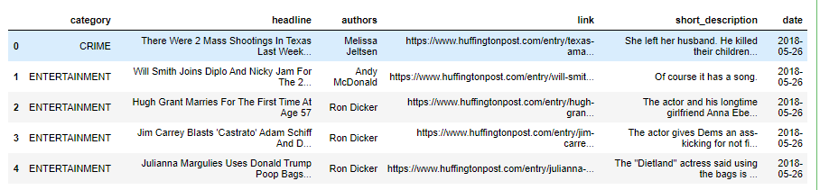

Now we can clearly see our data so first we need to perform the task which we have discus in the section 2.5 about class labels. After doing that. We need to select feature columns which we will use to train our model for this purpose, we will combine three columns

**headline**, **short_discription** and **authors** and join the text of them then make another column named as news and put that text in it. After that we will check is there any null value in the news column then drop it so now this news column is consider as our X text on which we will perform some other data preparation techniques and then use it to train or model.

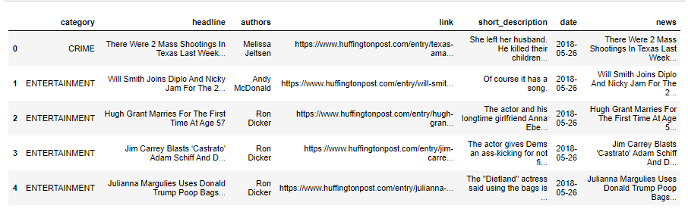

In this fig we can we have the news column. Ok now we have to perform 2 operation on this news columns first we need to replace all symbols from it and then remove all stop words from it for removing symbols we are using re module of python and for removing stopwords we are using nltk. For this task we have made a function named as clean_text you can see the source code file which will be given, so we apply clean_text function to the news columns.

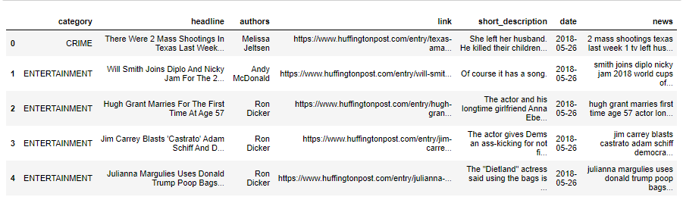

After that we can see this data in our news columns all stopwords are removed and now

We will split or data into train and test for this purpose we are using train_test_split function

From sklearn. We are using 70% data for training and 30% data for testing.

After splitting data we need to train our model but before there are two steps which are very important to do. As we are using multiple machine learning algorithms so before training our models these steps will be done before training every algorithm in our project so let’s discuss what are these two steps then we will start explaining our models.

## Count Vectorizer

The CountVectorizer give us simple way to both tokenize a collection of text and build a vocabulary of known words, basically It will give a particular unique number to each of unique word then it will count how many times are particular number is repeating. Process of giving a unique number to each word will be done by fit method which is in CountVectorizer class than counting the number of times that particular number is coming is done by transform method which is also present in CountVectorizer class.

Here for just better understanding I’m attaching a picture so we can have clear understand how CountVectorizer works.

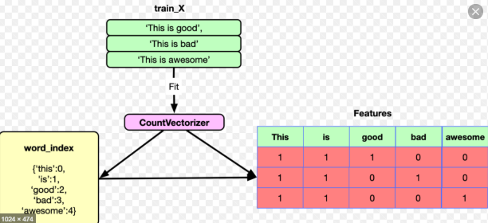

## TF-IDF

TF stands for Term Frequency: TF summarizes how often a given word appears within a document or we can say no of times a term occurred in a documents.

DF stands for document frequency which means that no of documents in which a term occurred

IDF stands for Inverse Document Frequency: IDF downscales words that appear a lot of across documents.

Here I’m attaching a picture just for example how tf-idf works.

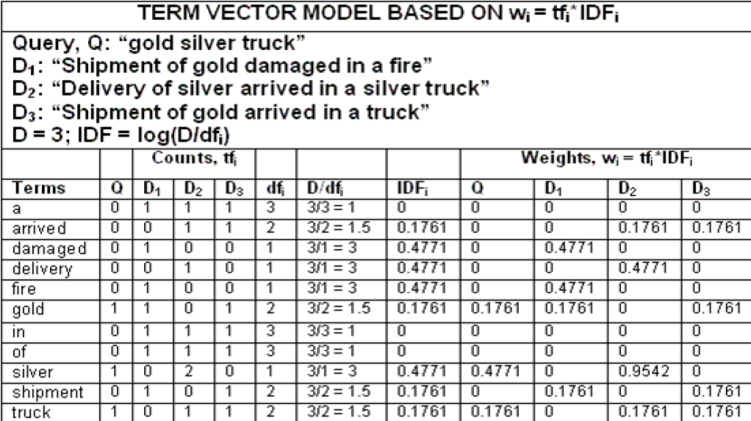

Now we know how CountVectorizer and TfidfTransformer works.

The first model we used for news classification is Naive Bayes Classifier for Multinomial.

## Data Mining Algorithms

## Naïve Bayes

The word Bayes in this algorithm comes from the Thomas Bayes, he was English statistician in 1970s he published a theory named as Bayes’ Theorem related to conditional probability. Naïve Bayes is based on the Bayes’ Theorem and the word naïve used because it makes the assumption that features of a measurement are independent of each other.

Naïve Bayes classifiers are collection of classification algorithms. It is not a single algorithm it is a pack of algorithms where all of them share a common principle, every pair of features being classified is independent of each other.

Here we are using Multinomial Naïve Bayes because we have multiple class labels.

Naïve Bayes first compute the probability of every class label and then with respect to it find out the conditional probability for every element in every feature and base on those probabilities it compute probability for every class w.r.t given x and choose the class label with the highest probability. Formula for naive Bayes is

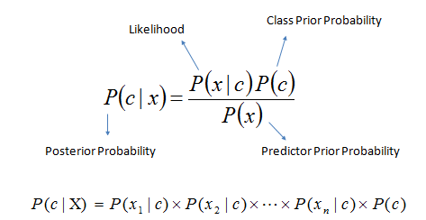

Just for Example how naïve Bayes work

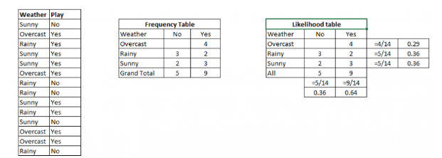

**Pros and Cons of Naïve Bayes**

Pros:

It is easy and fast to predict class because all the probabilities are pre-computed in the Naive Bayes algorithm, the prediction time of this algorithm is very efficient.

It needs only one pass on entire data to calculate the posterior probabilities for each value of the feature in the data. So, when we are dealing with large datasets or low-budget hardware, it will be feasible choice as compare to other data mining algorithms.

Cons:

If any categorical feature has any category in test data, which is not in training data, then model will assign a 0 probability and then it will not able to make prediction. This is known as 0 Frequency. To solve this, we can use the smoothing technique. One of the simplest smoothing techniques is called Laplace estimation.

## Decision Tree

First article I've had the option to find that builds up a " Decision tree" approach dates to 1959 and a British analyst, William Belson, in a paper titled Matching and Prediction on the Principle of Biological Classification, (JRSS, Series C, Applied Statistics, Vol. 8, No. 2, June, 1959, pp. 65-75), whose theoretical portrays his methodology as one of coordinating populace tests and creating rules for doing as such: In this article Dr Belson depicts a procedure for coordinating populace tests. This relies upon the blend of experimentally created indicators to give the best accessible prescient, or coordinating, composite. The basic standard is very unmistakable from that intrinsic in the numerous relationship strategy.

Decision Tree Analysis is a general, prescient demonstrating device that has applications spreading over various zones. By and large, Decision trees are built by means of an algorithmic methodology that recognizes approaches to part an informational index dependent on various conditions.

Basically it is a greedy algorithm. In this algorithm Tree is constructed in a top down recursive and divide-and-conquer manner. At start, all the training examples are the root. Then most important attributes are selected on the based on entropy, information gain.

There are many algorithms for decision tree for example.

Hunts Algorithm, CART, ID3, C4.5, C5.0

For ID3 we need to understand two terms

**Entropy**

**Entropy is the measure of uncertainty associated with a random measure, higher entropy means high uncertainty low entropy means low uncertainty**

**It is also known as measure of dispersion. Formula is:**

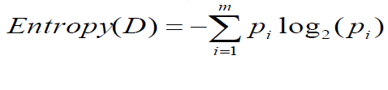

**Information Gain: Attribute Selection Measure**

**Select the attribute with the highest information gain.**

**Formula for info gain is:**



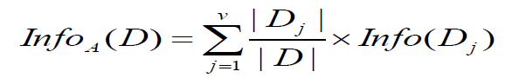

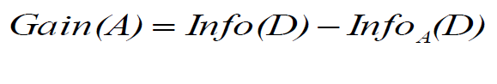

**There is another better way for attribute selection which is called as gini index.**

* + **If data set contains examples from n classes then formula for gini index is:**
    - * 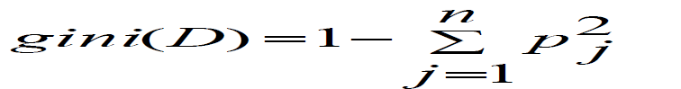

Its works like this in start spit the records based on an attribute, then test that optimizes certain criterion. Now when stop splitting it stop splitting when all records in a table belongs to same class.

**Pros and Cons of Decision Tree:**

Pros

* Extremely fast at classifying unknown records
* Easy to interpret for small-sized trees
* Accuracy is comparable to other classification techniques for many simple data sets

Cons

* Not scalable (add one attribute, all tree needed to be computed again)
* Not good accuracy for large dataset
* Not robust (less handling of a big set of attributes)

## Random Forest

RF is a gathering learning strategy utilized for arrangement and relapse. Created by Breiman (2001), the technique consolidates Breiman's sacking testing approach ((1996a), and the arbitrary choice of highlights, presented autonomously by Ho (1995); Ho (1998) and Amit and Geman (1997), so as to build an assortment of choice trees with controlled variety. Utilizing stowing, every choice tree in the group is developed utilizing an example with substitution from the preparation information. Factually, the example is probably going to have about 64% of occasions showing up at any rate once in the example. Examples in the example are alluded to as in-sack occasions, and the rest of the occurrences (about 36%) are alluded to as out-of-pack cases. Each tree in the gathering goes about as a base classifier to decide the class mark of an unlabeled case. This is done through dominant part casting a ballot where every classifier makes one choice for its anticipated class mark, at that point the class name with the most votes is utilized to characterize the occasion.

The RF consolidates hundreds or thousands of decision trees, prepares everyone on a somewhat unique arrangement of the perceptions, parting hubs in each tree thinking about a predetermined number of the highlights. The last expectations of the irregular woods are made by averaging the forecasts of every individual tree.

**Pros and Cons of Random Forest:**

Pros

* The predictive performance can compete with the best supervised learning algorithms.
* Forest has the power to handle large data sets with higher dimensionality and identity most significant variables so it is considered as one of the dimensionality reduction method.

Cons

* An ensemble model is inherently less interpretable than an individual decision tree
* Training a large number of deep trees can have high computational costs (but can be parallelized) and use a lot of memory

**Support Vector Machine**

The first SVM calculation was created by Vladimir N. Vapnik and Alexey Ya. Chervonenkis in 1963. In 1992, Bernhard E. Boser, Isabelle M. Guyon and Vladimir N. Vapnik proposed an approach to make nonlinear classifiers by applying the piece stunt to greatest edge hyperplanes

SVM is a machine learning algorithm which belongs to supervised learning it can be used for classification or regression issues. It utilizes a method called the kernel to change your information and afterward dependent on these changes it finds an ideal limit between the potential yields.

Properties of SVM:

Duality| Kernels| Margin| Convexity| sparseness

The basic concept of svm is to find a liner decision surface or line which is called as hyper plane that can separate classes and has the largest distance this distance is known as margin between the border line elements of both classes.

Hyper plane is a liner decision surface that split the space into two parts, yes of course it will be a binary classifier. The equation of hyper plane is defined by point p0 and perpendicular vector to plan w at that point.

A Convex function is function if it lies below the straight line segment connecting two points, for any two points in the interval

Kernel method is a similarity function that we provide to a machine learning algorithm, it takes two inputs and output how similar they are, while the similarity criteria is differs from one kernel to another

**Pros and Cons of Support Vector Machine**

Pros

* SVM is more effective in high dimensional spaces
* SVM is relatively memory efficient
* SVM is effective in cases where number of dimensions is greater than the number of samples.

Cons

* SVM algorithm is not suitable for large data sets.
* Does not perform well in case of overlapped classes
* Selecting the appropriate kernel function can be tricky.

**Logistic Regression**

Logistic Regression's history can be followed back to the nineteenth century when it was first used to portray the development pace of populaces by Quetelet and Verhulst. Today, strategic relapse is broadly utilized in the field of medication and science. The study of disease transmission is additionally a zone where calculated relapse is broadly utilized for recognizable proof of hazard factors for infections and to anticipate preventive medicine. Studies worried about general wellbeing and related strategy choices utilize calculated relapse as a significant factual device.

Calculated relapse means to quantify the connection between an absolute ward variable and at least one autonomous factors (typically consistent) by plotting the needy factors' likelihood scores. A straight out factor is a variable that can take esteems falling in constrained classes as opposed to being consistent.

Logistic Regression's utilizes relapse to anticipate the result of a clear cut dependent variable based on indicator factors. The plausible results of a solitary preliminary are displayed as an element of the logical variable utilizing a calculated capacity. Strategic displaying is done on absolute information which might be of different sorts including double and ostensible. For instance, a variable may be twofold and have two potential classes of 'yes' and 'no'; or it might be ostensible state hair shading possibly dark, earthy colored, red, gold and dim.

**Pros and Cons of Logistic Regression's**

Pros

* Logistic regression works well for predicting categorical outcomes
* Efficient, and can be distributed (ADMM)
* Robust to noise

Cons

* Logistic regression attempts to predict based on a set of independent variables, but if we include the wrong independent variables, the model will have little to no predictive value.
* Logistic regression cannot predict continuous outcomes

## Modeling

## Experiment one (Naïve Bayes)

**Build Naïve Bayes model and predict news classes**

Aim: to predict a news belongs to which class or category

**Methodologies**

Before we have already preprocess the data now we need to make naïve Bayes model then train it and then predict using test data.

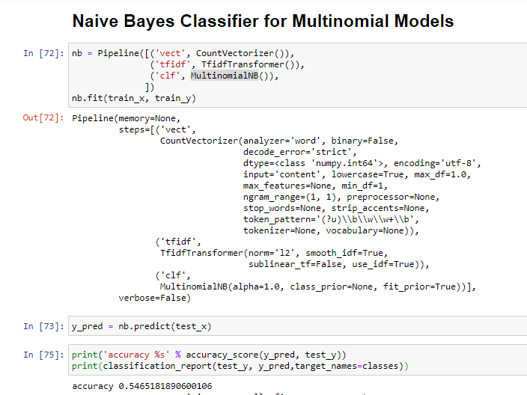

### Conclusion

Here we can see that we make a pipe line and in which we have done CountVectorize and then TfidTransform which we have discuss above after that we make a model and then fir it using train_x and train_y and then predict using test_x which gives result y_pred and then we print calculate the accuracy sore using y_pred which are predicted values and test_y are real values. And so our accuracy is 54%

## Experiment Two (Decision Tree)

**Build Decision Tree model and predict news classes**

Aim: to predict a news belongs to which class or category

**Methodologies**

Before we have already preprocess the data now we need to make Decision Tree then train it and then predict using test data.

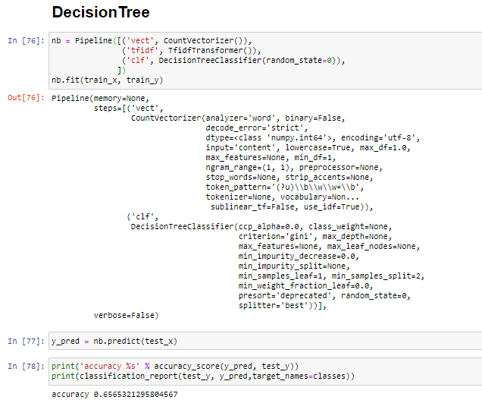

### Conclusion

We can see decision tree accuracy is more than naïve Bayes. 65% Accuracy.

## Experiment Three (Random Forest)

**Build Random Forest model and predict news classes**

Aim: to predict a news belongs to which class or category

**Methodologies**

Before we have already preprocess the data now we need to make Random Forest then train it and then predict using test data.

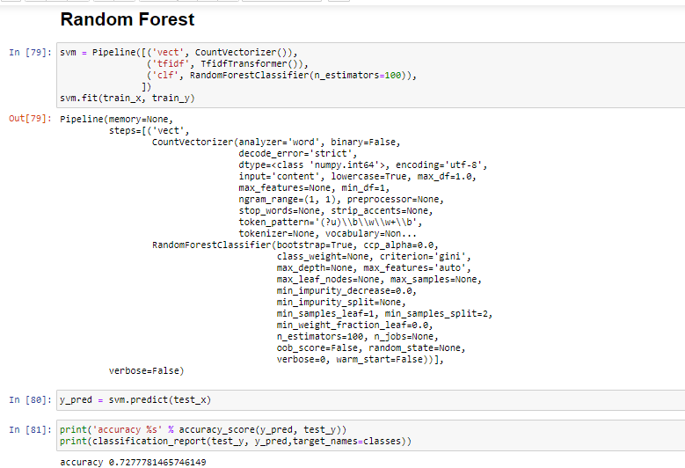

### Conclusion

Better then decision tree 72% accuracy

## Experiment Four (Support Vector Machine)

**Build SVM model and predict news classes**

Aim: to predict a news belongs to which class or category

**Methodologies**

Before we have already preprocess the data now we need to make SVM model then train it and then predict using test data.

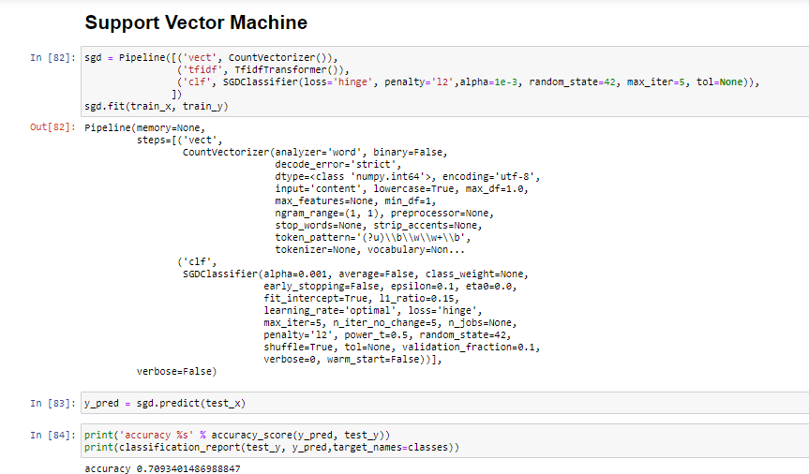

### Conclusion

70% Accuracy

## Experiment Five (Logistic Regression)

**Build Logistic Regression model and predict news category**

Aim: to predict a news belongs to which class or category

**Methodologies**

Before we have already preprocess the data now we need to make Logistic Regression model then train it and then predict using test data.

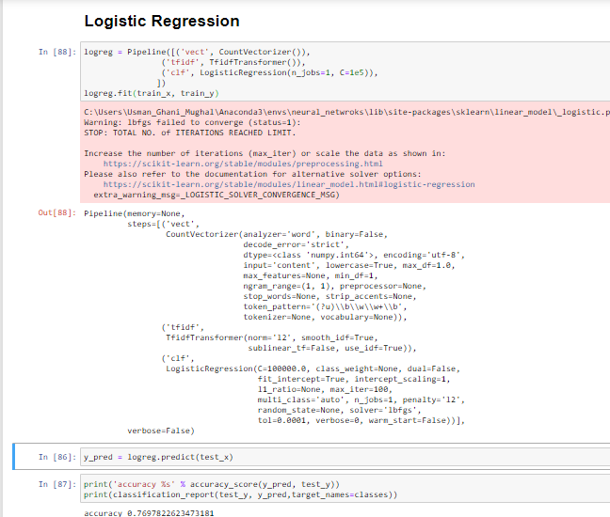

### Conclusion

Accuracy of 76% better then all.

# Data Visualization

### Visualization for experiment one

### 

### This is confusion matrix for experiment one, may be this is not clear here but for clear results I have attached the .html fie in which you can see clear results.

### Visualization for experiment two

### Confusion matrix for decision tree

### 

### Visualization for experiment three

### Confusion matrix for Random Forest

### 

### Visualization for experiment Four

**Confusion matrix for Support Vector Machine**

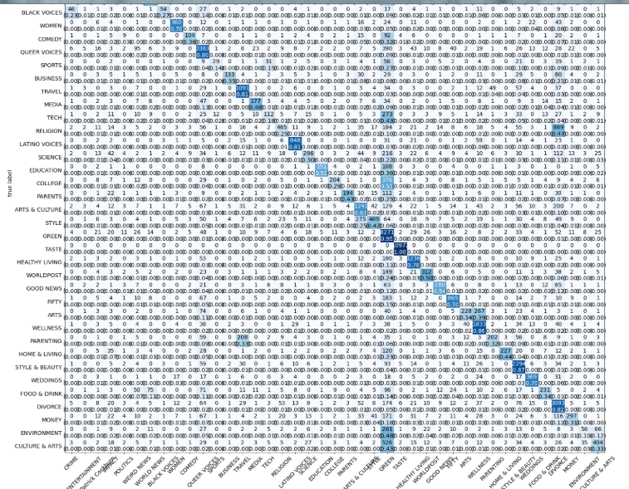

### Visualization for experiment Five

**Confusion matrix for Logistic Regression**

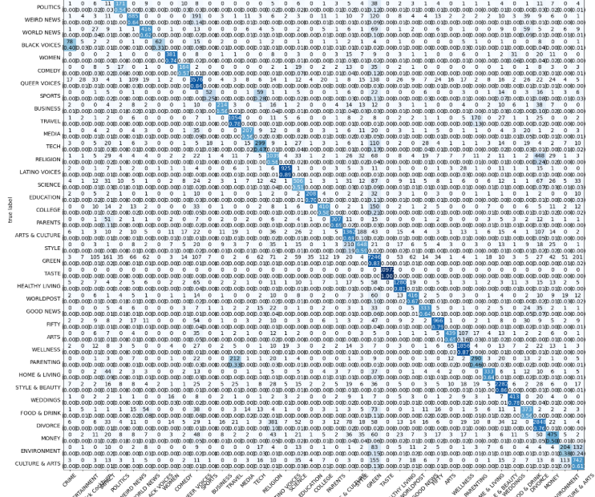

1. **References**

[Online] Available from: <https://machinelearningmastery.com/naive-bayes-for-machine-learning/> [Accessed 23 May 2020]

[Online] Available from: <https://monkeylearn.com/blog/introduction-to-support-vector-machines-svm/> [Accessed 23 May 2014]

[Online] Available from: <https://towardsdatascience.com/decision-trees-in-machine-learning-641b9c4e8052> [Accessed 25 May 2020]

[Online] Available from: <https://www.tutorialspoint.com/machine_learning_with_python/machine_learning_with_python_classification_algorithms_random_forest.htm> [Accessed 24 May 2020]

[Online] Available from: <https://medium.com/text-classification-algorithms/text-classification-algorithms-a-survey-a215b7ab7e2d> [Accessed 25 May 2020]

[Online] Available from: <https://www.sciencedirect.com/topics/medicine-and-dentistry/logistic-regression-analysis> [Accessed 28 May 2020]